育達高中12月4日下午1時「認識美國音樂」演講人簡介
美國在台協會美國中心 阮家齊 主任

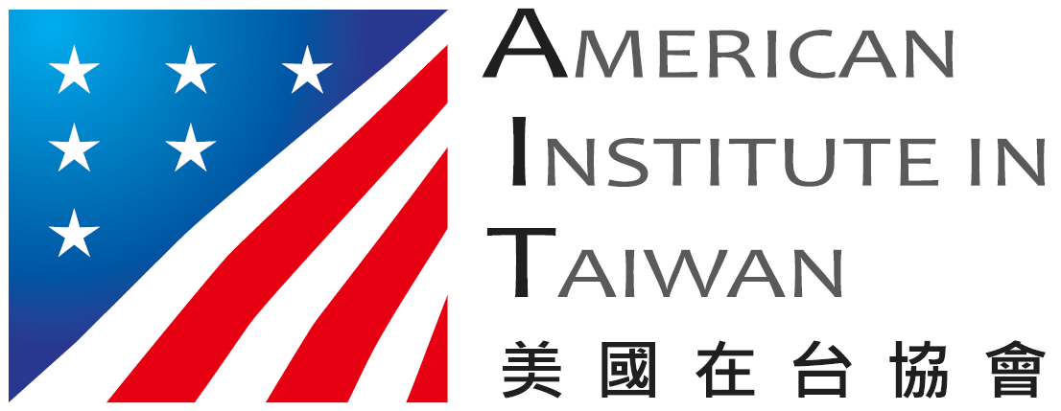
Ryan Roberts
Director, American Center
American Institute in Taiwan

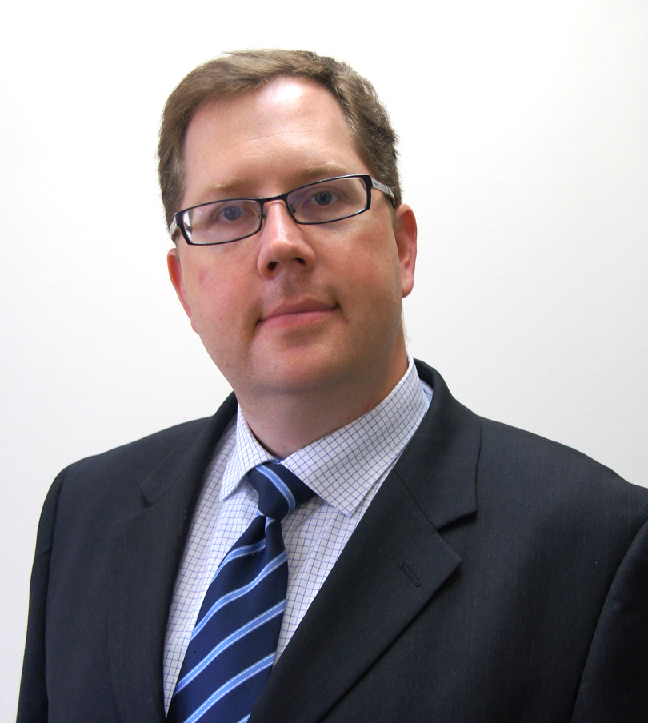
Ryan Roberts serves as the Cultural Affairs Officer in the Public Diplomacy Section of the American Institute in Taiwan (AIT). Mr. Roberts concurrently serves as Director of AIT's American Cultural Center, responsible for strengthening ties between educational and cultural institutions in Taiwan and the United States.

Mr. Roberts joined the Foreign Service in 2004. He served previously in Guangzhou (2004-2007) and in Riga, Latvia (2007-2010). Prior to becoming a Foreign Service Officer, He worked as a human resources consultant in Houston, Texas and, before that, in the television industry in Milwaukee, Wisconsin. From 1996 - 1998 Mr. Roberts lived in central and southern Taiwan.

Mr. Roberts was born and raised in Milwaukee, Wisconsin. He holds a Bachelors degree in Political Science from Brigham Young University Hawaii and speaks Latvian and Mandarin Chinese. He and his wife have three children.
阮家齊
美國在台協會美國中心主任

阮家齊（Ryan Roberts）於2011年6月20日就任美國在台協會美國中心主任，他同時擔任美國在台協會文化新聞組文化科科長，負責促進美國與台灣文教機構之間的合作與交流。

阮家齊於2004年加入美國外交官的行列，曾派駐於中國廣州（2004-2007年）和拉脫維亞的里加（2007-2010年）。在成為外交官之前，他曾在德州休士頓擔任人力資源顧問；在此之前，他在威斯康辛州的密爾瓦基任職於電視業。1996-1998年間，阮家齊曾定居於台灣中南部。

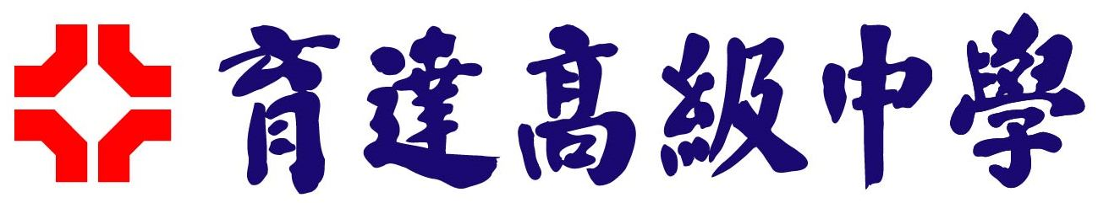
阮家齊在威斯康辛州的密爾瓦基出生和成長。他在楊百翰大學-夏威夷分校取得政治學學士學位，會說拉脫維亞語和中文。他和妻子育有三名子女。

